Assignment – 3.1
k. Uma maheshwari
2303a52430
Batch 44
Task 1:Zero-Shot Prompting (Palindrome Number Program):
Prompt: Write a Python function that checks whether a given integer number is a palindrome.
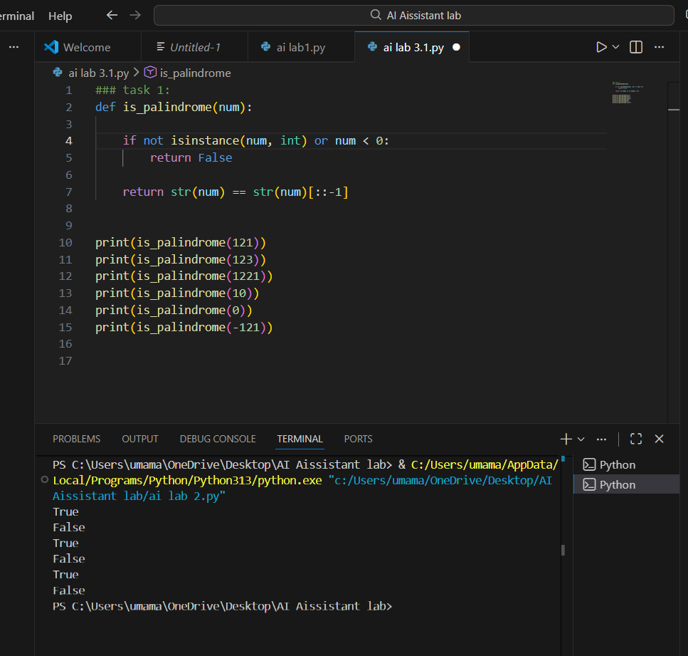
Observation: The zero-shot prompted palindrome program generally works correctly for common positive numbers and successfully identifies whether a number reads the same forwards and backwards. However, the AI-generated code often does not explicitly handle important edge cases such as negative numbers, which should not be considered palindromes, or non-integer inputs, which can cause unexpected behavior. Single-digit numbers are usually handled correctly by default, but this is not always clearly stated in the logic.

Task 2: One-Shot Prompting (Factorial Calculation)
Prompt: Write a Python function to calculate the factorial of a given number.
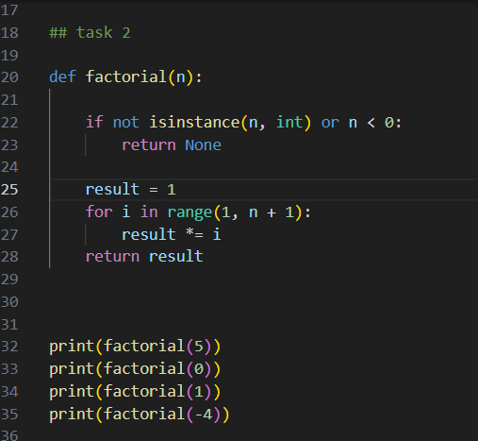
Output:
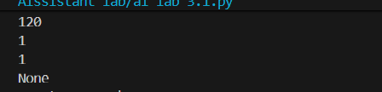
Observation: Compared to a zero-shot solution, the one-shot prompted code is usually clearer and more structured because the input–output example guides the AI toward the expected logic. It often produces an iterative and easy-to-understand implementation, reducing ambiguity and avoiding common issues like unnecessary recursion. As a result, the one-shot solution tends to be more readable, beginner-friendly, and reliable in terms of correctness.
Task 3: Few-Shot Prompting (Armstrong Number Check)
Prompt: Write a Python function that checks whether a given number is an Armstrong number and prints the appropriate result.
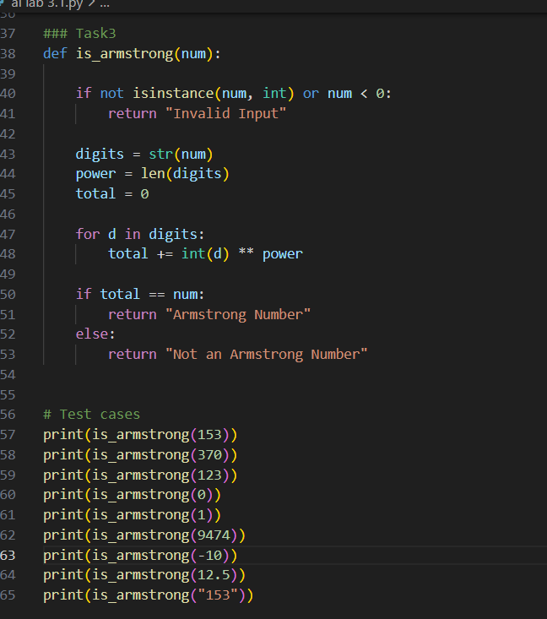
Output:
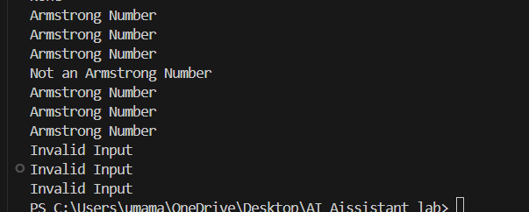
Observation: Providing multiple examples helps the AI clearly understand the pattern for identifying an Armstrong number, leading to more accurate and well-structured code. The few-shot prompt guides the AI to correctly calculate the sum of powers of digits based on the number of digits, improving correctness compared to zero-shot or one-shot approaches. It also reduces ambiguity in output formatting. However, the generated code may still need additional checks for boundary values (such as single-digit numbers) and invalid inputs (like negative numbers or non-integer values) to make the solution fully robust.
TASK 4; Context-Managed Prompting (Optimized Number
Classification)
Prompt:Write an optimized Python function that accepts an integer or numeric string as input, validates it, and classifies the number as Prime.
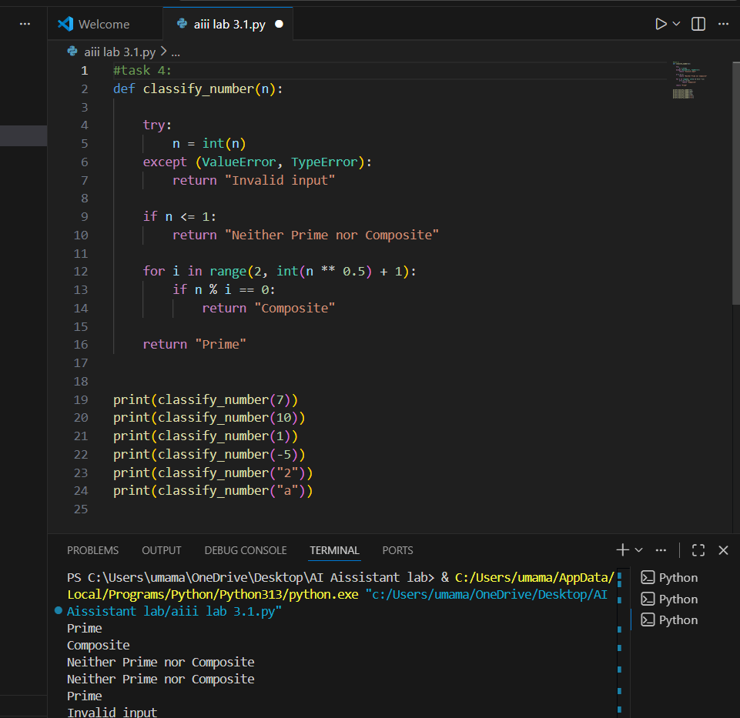
Observation: Context-managed prompting produces more efficient and reliable code compared to earlier prompting strategies. Clear instructions and constraints help the AI include input validation, handle edge cases, and use optimized logic, resulting in higher accuracy and better performance.
TASK 5; Zero-Shot Prompting (Perfect Number Check)
Prompt:
Write a Python function that checks whether a given integer is a perfect number and returns an appropriate result.
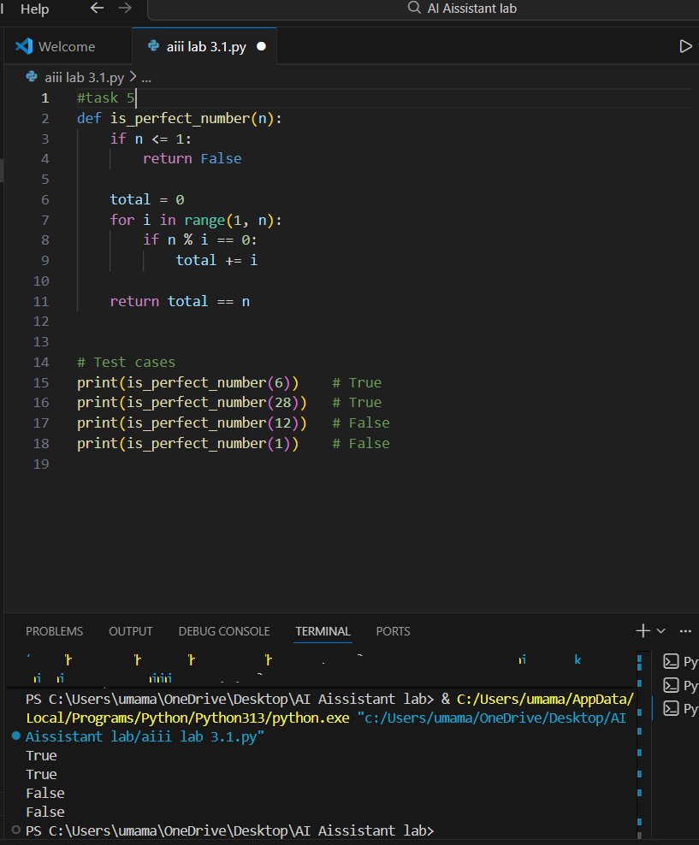
Observation: The zero-shot generated code correctly identifies perfect numbers for common inputs such as 6 and 28. However, it is inefficient for large numbers because it checks all values from 1 to n−1 instead of limiting the loop to √n. Input validation for non-integer values is also missing. Adding optimization and validation would improve performance and robustness.
TASK 6: Few-Shot Prompting (Even or Odd Classification with
Validation)
Prompt: Write a Python program that accepts a number, validates the input,and prints whether the number is Even or Odd.

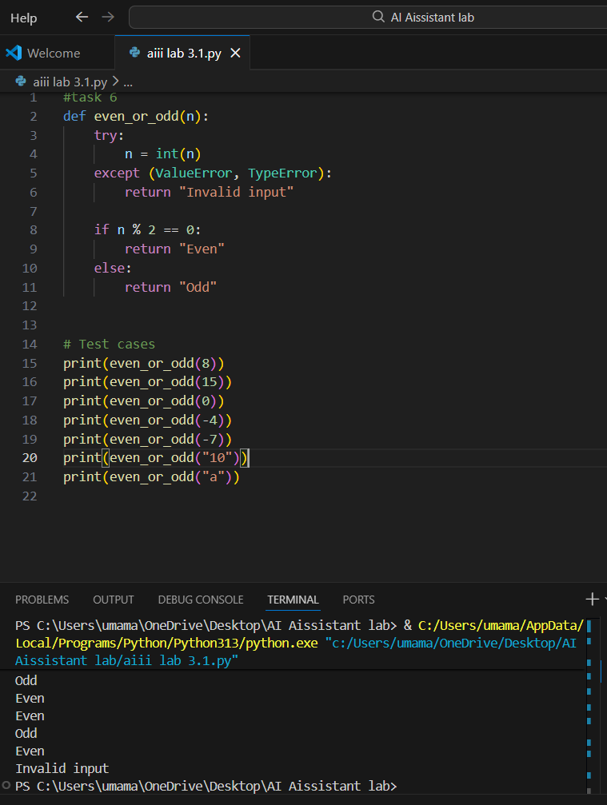observation: Providing multiple examples helps the AI clearly understand both the expected output format and the need to handle special cases like zero. The few-shot prompt improves input validation by encouraging the handling of numeric strings and rejecting invalid inputs. As a result, the generated code is clearer, more accurate, and robust, correctly classifying negative numbers while safely handling non-integer inputs.

